273/1
Qn | Marks
Objct
1
2
3
Sec B
Total

GEOGRAPHY
Paper 1
Nov 2020
2 ½ hrs
ST. MARYS’ KITENDE
Uganda Certificate of Education
RESOURCEFUL MOCK EXAMINATION
GEOGRAPHY
Paper 1
Time: 2hours 30minutes

INSTRUCTIONS TO CANDIDATES

- This paper consists of parts I and II.
- Part I and section A of part II are compulsory.
- Answer only one question from section B of part II.
- Answers to all questions must be written in the answer booklet provided.

PART I
OBJECTIVE TYPE QUESTIONS
Answer all the 30 questions

1. The Yatta plateau in Kenya was formed by the process of
A. faulting C. volcanicity
B. warping D. denudation

2. The major economic activity carried out on the slopes of Mt Muhavura is
A. agro forestry C. livestock keeping
B. crop cultivation D. wildlife conservation

3. The weathering process by which rocks absorb water and break up is called
A. hydrolysis C. exfoliation
B. hydration D. carbonation

4. Man made lakes in Kenya are mainly found along river
A. Tana C. Turkwell
B. Nzoia D. Nyando

5. The rainfall distribution pattern of northern Kenya is mainly influenced by
A. relief C. vegetation cover
B. latitude D. wind systems

6. The major economic activity carried out in the dry corridor of western Uganda is
A. cattle ranching C. plantation farming
B. wildlife conservation D. irrigation farming

7. A double-maxima of rainfall in Tanzania is experienced around
A. Kigoma C. Dodoma
B. Bukoba D. Mombasa

8. Rapid population increase in the urban areas of East Africa is mainly caused by
A. better health care C. improved food security
B. polygamous marriages D. internal migrations

9. Horticulture is well developed in the Kenya highlands mainly because of
A. heavy rainfall C. reliable market
B. fertility of soil D. efficient transport

10. Sugar cane growing in Kinyara plantation has mainly been favoured by
A. heavy rainfall C. fertile soils
B. abundant land D. gentle slopes

11. Soil erosion on the slopes of Mt. Meru has mainly been controlled by
A. terracing land C. re afforestation
B. mixed farming D. contour farming

12. The growing of cloves on the western parts of Zanzibar is mainly favoured by
A. heavy rainfall C. warm temperatures
B. fertile soils D. gently sloping relief

13. The major problem facing gold mining activity in north eastern Uganda is
A. shortage of power C. limited skilled labour
B. inadequate capital D. low level of technology

14. The major problem caused by limestone mining activity at Tororo is
A. degradation of landscape C. lowering of water tables
B. pollution of environment D. destruction of vegetation

15. Which of the following cash crops is mainly grown around Morogoro in Tanzania?
A. sisal C. wheat
B. coffee D. pyrethrum

16. The major factor which has favoured tea growing in Kabarole district is
A. ready market C. abundant labour
B. fertile soils D. improved transport

17. The major benefit of Doho rice scheme to the people of eastern Uganda is
A. supply of abundant food C. improved social services
B. provision of employment D. diversification of economy

18. The Kaputiei ranching scheme has mainly benefited the Maasai through
A. acquisition of life skills C. provision of veterinary services
B. development of infrastructures D. formation of co operatives

19. Which of the following lakes is Lava Dammed?
A. Mulehe C. Bisina
B. Kwania D. Rukwa

20. The industrial development of northern Kenya is mainly limited by
A. market C. transport
B. power supply D. raw materials.

21. Industrial development at Namanve park in Kampala has mainly been favoured by
A. abundant land C. cheap power
B. ready market D. government policy.

22. Which one of the following industries is located in Mbarara town?
A. pharmaceuticals C. milk processing
B. leather tanning D. meat packing

23. The major cause of deforestation in the islands of Kalangala district is
A. lumbering C. fire outbreaks
B. crop cultivation D. boat making

24. The major problem facing marine fishing along the coast of Kenya is?
A. water pollution C. limited market
B. poor technology D. rocky outcrops

25. The major benefit of Mabira forest to Lake Victoria basin is
A. climate modification C. timber production
B. wildlife conservation D. water catchment

26. The swamp vegetation along River Kafu is mainly used for
A. mulching gardens C. grazing livestock
B. craft manufacture D. wildlife conservation

27. Commercial fishing on Lake Rukwa is mainly hindered by
A. steep escarpments C. shortage of market
B. limited fish species D. poor fishing equipment

28. Which of the following game parks are found in Tanzania?
A. Tsavo and Marsabit C. Serengeti and Ruaha
B. Biharamulo and Mara D. Amboseli and Rungwa.

29. The major problem caused by rapid urbanisation in East Africa is?
A. shortage of land C. waste management
B. increased crime D. high unemployment

30. The major means of transporting petroleum from Mombasa to Eldoret is by
A. road C. railway
B. water D. pipeline

PART II
MAPWORK, PHOTOGRAPH INTERPRETATION, FIELD WORK AND EAST AFRICA

Answer four questions from part II, including questions 1, 2 and 3 which are compulsory.

SECTION A
COMPULSORY QUESTION: MAPWORK.
Answer all parts of this question.

1. Study the 1:50,000 (UGANDA): NYARWEYO map extract, Series Y732, part of sheet 87/4, Edition 3 – U.S.D and answer the questions that follow:

(a) Identify the
(i) man-made feature found at grid reference 104364
(ii) physical feature found at grid reference 164262 (2 marks)

(b) (i) Measure and state in Km² the area covered by Butemba sub county.
(2 marks)
(ii) State with evidence the hemisphere in which the area shown on the
map extract is located. (2 marks)

(iii) State with evidence the direction of flow of river Mpongo. (2 marks)

(c) Draw a sketch map of the area shown on the map extract and on it mark
and name:
(i) clustered settlement
(ii) drainage features
(iii) transport route
(iv) forest reserve (6 marks)

(d) (i) Describe the relationship between relief and transport in the area
shown on the map extract. (4 marks)

(ii) What evidence is there to show that the area shown on the map extract is generally flat? (2 marks)

COMPULSORY QUESTION: PHOTOGRAPHIC INTERPRETATION.
1. Study the photograph provided below and answer the questions that follow:

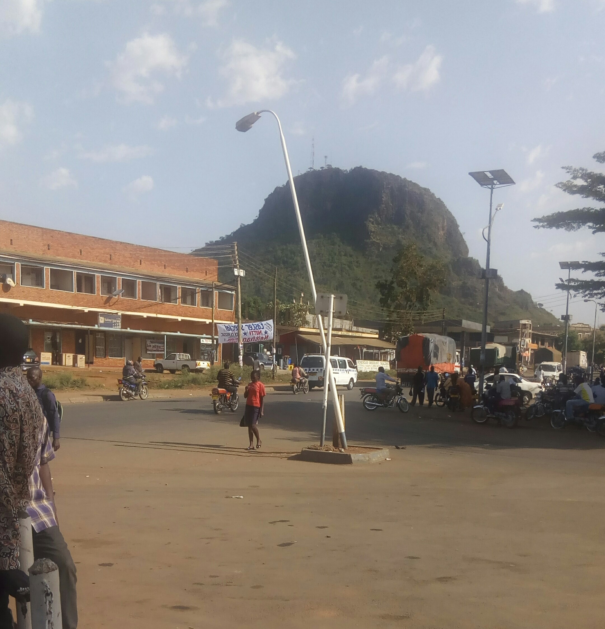

- (i) Draw a landscape sketch of the area shown on the photograph and on it mark and name
- settlements
- transport route
- physical feature. (3 marks)

(b) Describe the process of formation of the relief feature shown in the background of the photograph. (5 marks)

- Outline the:
- benefits (4 marks)
- disadvantages of the above relief feature to the people living around this area. (2 marks)

(d) Suggest any one area in East Africa where the photograph could have been taken from. (1 mark)

3. COMPULSORY QUESTION: FIELDWORK
For any one fieldwork study you have carried out on a livestock farm or fish landing site:

(a) State the:
(i) topic of your study. (2 marks)
(ii) objectives of your field work study. (2 marks)

(b) Draw a cross section of the area of your field work study and on it mark
and name the:
(i) physical features
(ii) land use types. (5 marks)

(c) Explain the findings of your field work during your study of the area
stated above. (4 marks)

(d) Explain the difficulties you faced in the field while carrying out this field
work study. (2 marks)

SECTION B: EAST AFRICA (20 MARKS)
Answer only one question from this section.

4. (a) Draw a sketch map of East Africa and on it, mark and name:

(i) Ports: Mombasa and Dar es Salaam
(ii) Mountains: Kenya and Kilimanjaro
(iii) Islands: Lamu and Zanzibar. (7 marks)

(b) Describe the conditions which have favoured the formation of coral reefs in East Africa. (6 marks)

(c) Explain the value of coral reefs to the economic development of East Africa. (4 marks)

(d) Outline the problems caused by coral reefs to the people living along the coast of East Africa. (3 marks)

5. Study the table below showing Kenya’s export crops (2002-2003) in metric tonnes and answer the questions that follow:

Export Crop | 2002  (Metric Tonnes) | 2003  (Metric Tonnes)
Coffee  Tea  Sisal  Tobacco  Sugar cane  Oil palm | 17,000  88,000  9,ooo  108,000  37,ooo  2,000 | 63,000  294,000  24,000  50,000  39,000  33,000
Adapted: Africa Development Indicators, 2007 (p.21) World Development Indicators 2008 Pp 40-41. The World Bank, Washington D.C.

- Calculate the percentage change in Kenya’s food crop exports in
2002-2003. (5 marks)

(b) Draw a bar graph to represent the amount of Kenya’s food crop exports in
2003. (5 marks)

(c) Explain the problems which have limited the export of food crops in Kenya. (6 marks)

(d) Explain the steps being taken to promote export trade in East Africa.
(4 marks)

6. (a) Draw a sketch map of East Africa and on it mark and label the following:

(i) Rivers: Tana and Rufigi
(ii) Towns: Nairobi and Dodoma.
(iii) Irrigation Schemes: Kilombero and Mwea-Tebere. (7 marks)

(b) Describe the physical factors which have favoured the establishment of irrigation schemes in East Africa. (6 marks)

(c) Explain the benefits of irrigation farming to the economic development of
East Africa. (4 marks)

(d) Outline the problems caused by irrigation farming on the environment in
East Africa. (3 marks)

7. Study the table below showing arrival of tourists into East Africa
(1995-2006) and answer the questions that follow:

Tourist arrival into East Africa
Country | 1995 | 2006
Tanzania  Kenya  Uganda | 285,000  896,000  160,000 | 622,000  1,536,000  539,000
Total | 1,341,000 | 2,697,000
Adapted: World Development Indicators (2008). The World Bank, Washington D.C. Pp. 377-378.

(a)(i) Calculate the percentage change in the number of tourists’ arrival for each country in East Africa between 1995 and 2006. (4 marks)

(ii) Draw a pie-chart to show the arrival of tourists into East Africa in the year
2006. (4 marks)

(b) (i) Distinguish between a game reserve and a game park . (2marks)
(ii) State any two marine wildlife conservation areas in Kenya. (2 marks)

(c) Describe the factors which have promoted wildlife conservation in East
Africa. (6 marks)

(c) Outline the problems caused by the tourist industry on the environment in
East Africa. (2 marks)

END

